**Lab Practical #03:**

Study of different network devices in detail.

**Practical Assignment #03:**

1. Give difference between below network devices.

* Hub and Switch
* Switch and Router
* Router and Gateway

1. Working of below network devices:
   * Switch
   * Router
   * Repeater
   * Gateway
   * Modem

# Hub and Switch

|  |  |  |
| --- | --- | --- |
| No. | Hub | Switch |
| 1 | It functions in a physical layer. | It functions in the data link layer. |
| 2 | Switch allows packet switching. | There is a separate collision domain in the switch. |
| 3 | Hub follows broadcast transmission. | Switch follows three i.e., multicast, unicast, and broadcast type transmission. |
| 4 | In Hub, half duplex transmission technique is utilized. | In switch, full duplex transmission technique is utilized. |
| 5 | Hub does not allow packet filtering. | Switch allows packet switching. |
| 6 | There can be 4 ports in Hub. | 4 to 28 ports contained by a Switch. |

# Switch and Router

|  |  |  |
| --- | --- | --- |
| No. | Switch | Router |
| 1 | The switches in a network operate at the second layer (Data Link Layer) in an OSI model. | A typical router can easily operate at the third layer (Network) in an OSI model. |
| 2 | A switch does not offer any such services. | A router can easily offer QoS, NetFlow, and NAT services. |
| 3 | It is a type of multi-port bridge with 24/48 ports. | It is a networking device with 2/4/8 ports. |
| 4 | It is full-duplex in nature. Thus, no collision occurs here. | It is less duplex in nature. |
| 5 | It cannot perform NAT. | It can easily perform NAT. |

# Router and Gateway

|  |  |  |
| --- | --- | --- |
| No. | Router | Gateway |
| 1 | A router can easily operate on three and four layers only. | gateway can only operate on five layers. |
| 2 | You can also call a router an internet router or a wireless router. | You can also call a gateway a voice gateway, proxy server, or gateway router. |
| 3 | A typical router provides support for dynamic routing. | A gateway provides no support for dynamic routing. |
| 4 | You can deploy a router in specific appliances on their router hardware. | We deploy a gateway in a specific appliance, a physical server, or on a virtual server. |
| 5 | The router is available for only dedicated applications. | One can easily host a gateway on physical servers, virtual applications, as well as dedicated applications. |

**Working of below network devices:**

**---- Write Here ----**

1. **Switch:**
2. **Introduction:**

* Switch is Networking device , Mainly used to create a network.
* It works on data link layer in OSI model and has multiple switching ports, whichever PC connects to its ports, connects that computer to network.

1. **Working:**

* when **first-time devices** are connected to the switch it **broadcast a message,**
* Where it identifies the port number and MAC address and store it on its table, this information helps the switch to identify the destination device on the network.
* So after the broadcast, the switch knows which device is connected to which port number, So next time it does not need to broadcast a message, it will forward the information with the help of port number and Mac addresses.

1. **Router:**
2. **Introduction:**

* A router is a device that connects two or more packets switched networks and sub-networks.
* Terra several types of router is but most router is faster data between LANs and WANs. LAN is a group of connected devices restricted to a specific geographic area. A LAN usually requires a single router
* A WAN, by contrast is large network spread out over a vast geographic area. Large organization and companies that operates in multiple location across the country.

1. **Working:**

* A router analyses a destination IP address of a given packet header and compares it with the routing table to decide the packet's next path. The list of routing tables provides directions to transfer the data to a particular network destination. They have a set of rules that compute the best path to forward the data to the given IP address.
* Routers use a **modem** such as a cable, fiber, or DSL modem to allow communication between other devices and the internet. Most of the routers have several ports to connect different devices to the internet at the same time. It uses the **routing tables** to determine where to send data and from where the traffic is coming.
* A routing table mainly defines the default path used by the router. So, it may fail to find the best way to forward the data for a given packet. For example, the office router along a single default path instructs all networks to its internet services provider.
* There are two types of tables in the router that are **static and dynamic**. The static routing tables are configured manually, and the dynamic routing tables are updated automatically by dynamic routers based on network activity.

1. **Repeater:**
2. **Introduction**

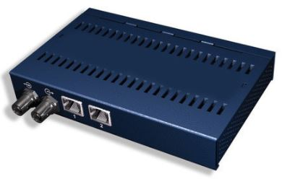

* In digital communication systems, a repeater is a device that receives a digital signal on an electromagnetic or optical transmission medium and regenerates the signal along the next leg of the medium. In electromagnetic media, repeaters overcome the attenuation caused by free-space electromagnetic-field divergence or cable loss. A series of repeaters make possible the extension of a signal over a distance.

1. **Working:**

* Repeaters remove the unwanted noise in an incoming signal. Unlike an Analog signal, the original digital signal, even if weak or distorted, can be clearly perceived and restored. With analog transmission, signals are restrengthened with amplifiers which unfortunately also amplify noise as well as information.

1. **Gateway:**
2. **Introduction:**

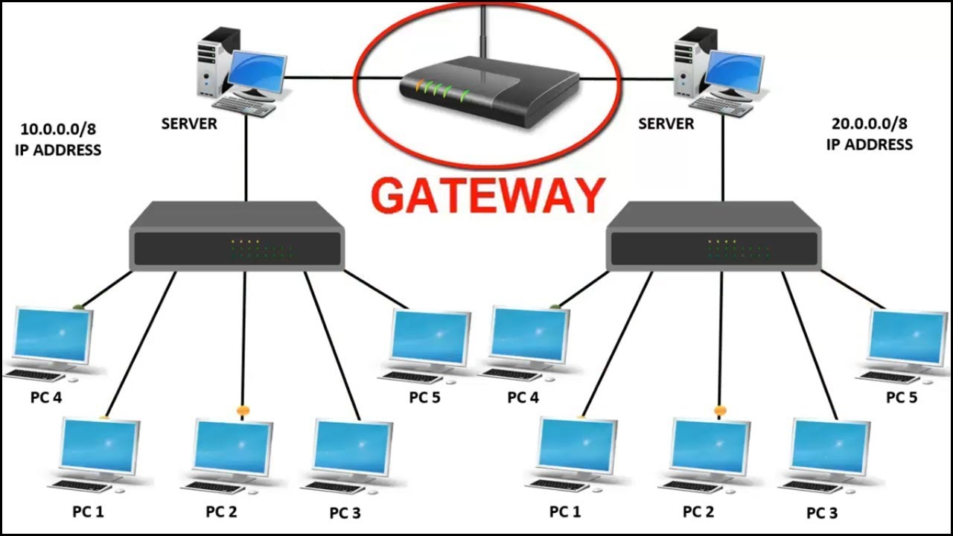

* Gateway is a hardware device, that is used to connect two dissimilal type of network
* It allow us to send & receive data through the einternet even it is LAN network

1. **Working:**

* A computer that sits between different networks or applications. The gateway converts information, data or other communications from one protocol or format to another. A router may perform some of the functions of a gateway. An Internet gateway can transfer communications between an enterprise network and the Internet. Because enterprises often use protocols on their local-area networks (LANs) that differ from those of the Internet, a gateway will often act as a protocol converter so that users can send and receive communications over the Internet.

1. **Modem:**
2. **Introduction:**

* Modem is a device that enables a computer to send or receive data over telephone or cable lines. The data stored on the computer is digital whereas a telephone line or cable wire can transmit only analog data.

1. **Working:**

* The main function of the modem is to convert digital signal into analog and vice versa. Modem is a combination of two devices − modulator and demodulator. The modulator converts digital data into analog data when the data is being sent by the computer. The demodulator converts analog data signals into digital data when it is being received by the computer.